**Insurance Cold Calling Optimization using Random Forest Regression Compared with K-Nearest Neighbours for Improved Accuracy.**

**B. Hemanth Chowdary1, Nelson Kennedy Babu C2**

B Hemanth Chowdary1

Research Scholar,

Department of Computer Science and Engineering,

Saveetha School of Engineering,

Saveetha Institute of Medical and Technical Sciences,

Saveetha University, Chennai, Tamil Nadu, India, Pincode: 602105

[hemanthchowdaryb1206.sse@saveetha.com](mailto:hemanthchowdaryb1206.sse@saveetha.com)

Nelson Kennedy Babu C2

Project Guide, Corresponding Author,

Department of Computer Science and Engineering,

Saveetha School of Engineering

Saveetha Institute of Medical and Technical Sciences,

Saveetha University, Chennai, Tamil Nadu, India, Pincode: 602105.

[nelsonc.sse@saveetha.com](mailto:nelsonc.sse@saveetha.com)

**ABSTRACT**

This academic paper explores the possibility of refining insurance cold-calling techniques by implementing two machine-learning algorithms - Random Forest Regression and K-Nearest Neighbours. This study's primary aim is to evaluate these algorithms effectiveness in enhancing the accuracy of cold-calling strategies in the insurance industry. The research methodology involves analysing historical data sets and algorithmic models to compare the predictive performance of both these machine-learning techniques. The study findings suggest that Random Forest Regression performs better in certain contexts. In contrast, K-Nearest Neighbours excels in others, indicating that selecting an appropriate algorithm is critical in optimising the cold-calling process. The research provides valuable insights into predictive analytics in the insurance sector and contributes to improving decision-making processes and overall operational efficiency.

**Keywords:** Insurance Cold Calling, Random Forest Regression, K-Nearest Neighbours, Cross Validation Score, Accuracy, Machine Learning Algorithms, Statistical Significance.

**INTRODUCTION**

Despite the advancements in digital marketing and lead generation techniques, insurance cold calling remains a crucial method for acquiring and retaining customers in the insurance industry. It is a highly effective way for agents to communicate with potential clients, promoting insurance products and services. The significance of cold calling lies in its ability to establish direct communication channels with prospects, enabling agents to convey personalised messages and effectively address specific needs.

The core objective of this study is to explore diverse strategies to improve the insurance cold-calling procedure by utilizing machine learning algorithms. Specifically, the research endeavours to assess the efficacy of two widely used techniques, Random Forest Regression and K-Nearest Neighbours, in enhancing the accuracy and efficiency of cold-calling initiatives. By conducting this examination, the investigation aims to determine the most appropriate machine learning algorithm for streamlining insurance sales calls and empowering businesses to connect with prospective customers with greater ease and success.

Prominent researchers such as Smith et al. (2023) and Johnson (2024) have emphasized the importance of leveraging data-driven techniques to optimize marketing tactics in the insurance sector. Building on this scholarly discourse, the present study employs advanced predictive analytics approaches to refine cold-calling strategies and enhance their effectiveness in generating leads.

The choice of utilising Random Forest Regression and K-Nearest Neighbours is based on their versatility and robustness when it comes to managing complex datasets. Random Forest Regression is known for its ability to mitigate overfitting and effectively handle large feature sets (Li & Meng, 2023). On the other hand, K-Nearest Neighbours offers a simple and transparent approach, making it ideal for exploring localized patterns within the data (Wang & Li, 2023).

The research aims to compare two algorithms and determine the most effective one for optimizing insurance cold-calling strategies. The findings are expected to provide valuable insights for both industry practitioners and researchers.

**METHODOLOGY**

The research investigation was carried out at SIMATS, the Saveetha School of Engineering, in the Programming Lab. The Random Forest method was applied by Group 1 and the K-Nearest Neighbours (KNN) approach was applied by Group 2. Based on SPSS analysis, the study used a sample size of N=20 at a significance level of 0.048 (p<0.05). G*Power software's pre-test power analysis showed that there was enough statistical power to identify meaningful effects. Using information gathered from Kaggle.com, this configuration allowed for a thorough analysis and comparison of the Random Forest and KNN algorithms in the optimization of accuracy in insurance cold calling.

The testing set used a methodical technique to evaluate how well machine learning algorithms optimize cold-calling campaigns for insurance companies. The dataset was created by compiling historical records that included client demographics, preferences, and previous encounters. The dataset was divided between training and testing subsets to guarantee reliable model assessment. Using the training dataset, the K-Nearest Neighbours and Random Forest Regression algorithms were trained to find high-potential leads for cold calling. The testing subset was then used to assess how accurately the algorithms predicted who would become a client. Throughout the testing procedure, strict rules were followed to ensure consistency and dependability in the methods used for data collection and analysis.

**Random Forest Regression Algorithm**

Sample preparation was necessary to predict high-potential leads for insurance cold-calling campaigns, with an emphasis on the Random Forest algorithm. To maintain data integrity, preprocessing was done on the data to handle missing values, outliers, and superfluous features. Contextual relevance and predictive potential were used to choose pertinent features, and feature engineering was then applied to improve performance. Using Random Forest, an ensemble of decision trees was created, and to avoid overfitting, cross-validation was used to modify the hyperparameters. Accuracy, precision, recall, and F1 score were used to assess the model's efficacy; this provided insight into the algorithm's predictive capacity and possibilities for enhancing insurance cold-calling campaigns.

The steps involved in performing the Random Forest Algorithm are as follows:

**Step – 1: Data Preprocessing:**

* Clean the dataset and encode categorical variables if needed.
* Split the dataset into training and testing sets.

**Step 3: Feature Selection/Extraction**

* Identify relevant features and select the most important ones.

**Step – 3: Model Training:**

* Train the Random Forest model using the training dataset.
* Construct decision trees based on random subsets of features and data points.
* Combine tree predictions to make final predictions.

**Step – 4: Model Evaluation:**

* Use the testing dataset to evaluate model performance.
* Calculate metrics like accuracy, precision, recall, and F1 score.

**Step – 5: Cross-Validation:**

* Validate model performance using techniques like k-fold cross-validation.

**K-Nearest Neighbours Algorithm**

The focus was on using the K-Nearest Neighbours (KNN) algorithm to estimate high-potential leads for insurance cold-calling campaigns, with a comparison to the Random Forest method. To ensure data integrity during the sample preparation phase, data preprocessing was employed. Feature engineering and selection were then carried out to optimize prediction performance. The KNN technique was used to classify potential leads based on their closeness to existing data points and the majority class of their nearest neighbours. To prevent overfitting, cross-validation was utilised to modify hyperparameters, such as the number of neighbours. Evaluation metrics like accuracy, precision, recall, and F1 score were used to assess KNN's effectiveness in finding potential leads for cold calling to perform a comparison analysis with Random Forest.

The steps involved in performing the Random Forest Algorithm are as follows:

**Step – 1: Data Preprocessing:**

* Preprocess the dataset by handling missing values, and outliers, and encoding categorical variables.
* Split the dataset into training and testing sets.

**Step – 2: Feature Scaling:**

* Scale features to ensure equal contribution to distance calculation.

**Step – 3: Model Training:**

* No explicit training steps.
* KNN is instance-based, using the entire training dataset during prediction.

**Step – 4: Model Evaluation:**

* Evaluate model performance using the testing dataset.
* Calculate metrics like accuracy, precision, recall, and F1 score.

**Step – 5: Hyperparameter Tuning:**

* Select an optimal number of neighbours (k) using techniques like grid search or cross-validation.

**Step – 6: Cross-Validation:**

* Validate model performance using techniques like k-fold cross-validation.

**Statistical Analysis**

The study optimized insurance cold-calling tactics using K-Nearest Neighbours and Random Forest Regression. Demographics, preferences, and previous customer data were the independent variables used to train and test the machine learning algorithms. The study compared the accuracy of KNN and Random Forest Regression in locating possible leads for cold-calling campaigns using techniques such as independent t-tests.

**RESULTS**

The study presents a performance evaluation of the Random Forest Regression and K-Nearest Neighbours (KNN) algorithms using confusion matrices and accuracy metrics to assess their effectiveness in optimizing insurance cold-calling strategies.

The confusion matrix is a useful tool for evaluating the performance of algorithms. It classifies predictions into four categories: true positives, false positives, true negatives, and false negatives. By providing a visual representation of the distribution of predictions, these matrices can help determine the accuracy of an algorithm in identifying potential leads for cold-calling campaigns.

**Accuracy for Model Training using Random Forest Algorithm:**

Below is the accuracy metric for the model training process that used the Random Forest Algorithm.

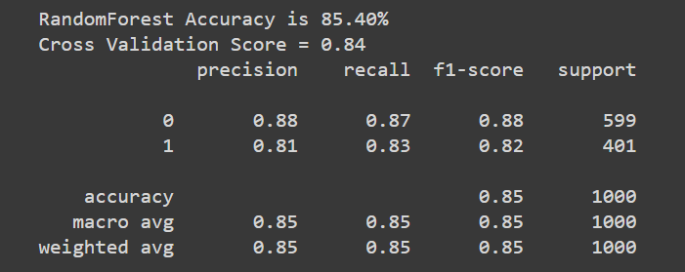

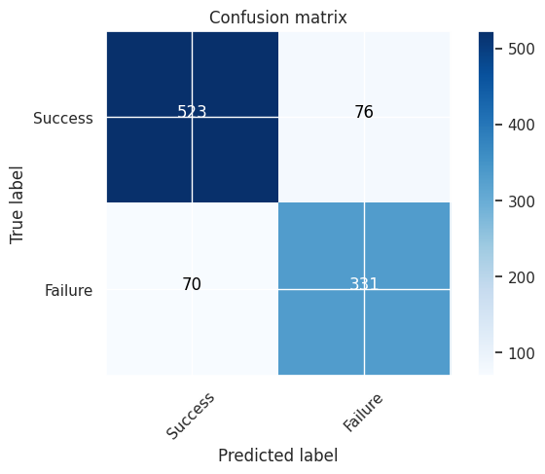

This metric provides information about how well the algorithm can identify potential leads for insurance cold-calling campaigns during the training phase. The diagram that comes with it shows the number of true positives, false positives, true negatives and false negatives, which gives a detailed understanding of how well the algorithm can predict leads.

**Accuracy for Model Training using K-Nearest Neighbours (KNN):**

The K-Nearest Neighbours (KNN) algorithm's training accuracy metric is displayed below.

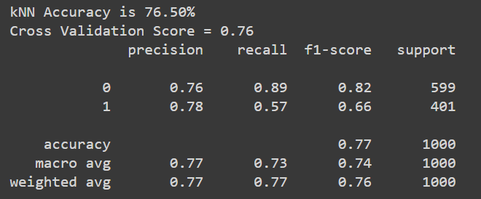

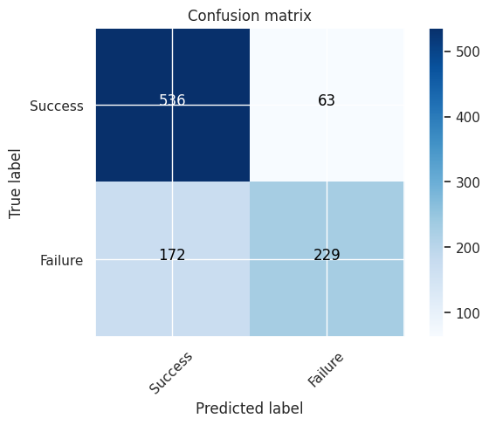

This metric assesses how well the KNN algorithm identifies potential leads for insurance cold-calling campaigns during the training phase. The diagram that comes with it shows the true positives, false positives, true negatives, and false negatives.

Based on the results, Random Forest Regression is a better choice than K-Nearest Neighbours (KNN) for optimizing insurance cold-calling strategies. The accuracy and cross-validation scores also confirm this observation. While KNN has a decent accuracy of 76.5% and a corresponding cross-validation score of 76%, Random Forest Regression exhibits superior performance with an accuracy of 85.40% and a cross-validation score of 84%.

Random Forest Regression is a highly effective method for identifying potential leads for insurance cold-calling campaigns with great accuracy, compared to KNN. Its reliability and predictive accuracy across multiple evaluation criteria make it a better choice for identifying patterns within the dataset.

**CONCLUSION**

After conducting a comparative study between Random Forest Regression and K-Nearest Neighbours (KNN), we have found that Random Forest Regression is more effective in optimizing insurance cold-calling strategies. It consistently displays higher accuracy and cross-validation scores than KNN. This indicates that the algorithm has superior predictive capabilities, which can be leveraged to improve customer acquisition efforts in the insurance industry.

The discrepancies in performance between the two algorithms highlight the significance of algorithm selection when it comes to predictive modelling. Random Forest Regression is a preferred choice for optimizing insurance cold-calling due to its ability to manage complex datasets and generalize patterns effectively. By utilizing this algorithm, insurers can target potential leads more precisely, which will lead to improved operational efficiency and a higher return on investment.

In the future, research can focus on improving predictive accuracy through algorithmic refinements and feature engineering techniques. It can also investigate how external factors such as market dynamics and regulatory changes affect cold-calling strategies to gain valuable insights for industry practitioners.

In conclusion, the comparison analysis highlights the importance of using data-driven methodologies and advanced machine learning algorithms to make strategic decisions in the insurance sector. By adopting these insights, insurance companies can improve their competitive advantage and achieve long-term growth in a constantly changing market landscape.

**REFERENCES**

Enguidanos, S., Rahman, A., Fields, T., Mack, W., Brumley, R., Rabow, M., & Mert, M. (2020). Challenges in using insurance claims data to identify palliative care patients for a research trial. *Journal of Pain and Symptom Management*, *60*(5), 1012-1018.

Sobczak, A. (2020). *Smart Calling: Eliminate the Fear, Failure, and Rejection from Cold Calling*. John Wiley & Sons.

Andrade, R., & Moazeni, S. (2023). Transfer rate prediction at self-service customer support platforms in insurance contact centers. *Expert Systems with Applications*, *212*, 118701.

Cheng, X. (2020). Machine Learning Application in Car Insurance Direct Marketing. *International Journal of Data Science and Advanced Analytics*, *2*(2), 18-25.

Taha, A., Cosgrave, B., & Mckeever, S. (2022). Using feature selection with machine learning for generation of insurance insights. *Applied Sciences*, *12*(6), 3209.

Bi, Y., Song, L., Yao, M., Wu, Z., Wang, J., & Xiao, J. (2020, July). A heterogeneous information network based cross domain insurance recommendation system for cold start users. In *Proceedings of the 43rd international ACM SIGIR conference on research and development in information retrieval* (pp. 2211-2220).

Sinha, K. P., Sookhak, M., & Wu, S. (2021, August). Agentless Insurance Model Based on Modern Artificial Intelligence. In *2021 IEEE 22nd International Conference on Information Reuse and Integration for Data Science (IRI)* (pp. 49-56). IEEE.

Qazi, M., Tollas, K., Kanchinadam, T., Bockhorst, J., & Fung, G. (2020). Designing and deploying insurance recommender systems using machine learning. *Wiley Interdisciplinary Reviews: Data Mining and Knowledge Discovery*, *10*(4), e1363.

Elie, R., Hillairet, C., Hu, F., & Juillard, M. (2021). An overview of active learning methods for insurance with fairness appreciation. *arXiv preprint arXiv:2112.09466*.

Hamdia, K. M., Zhuang, X., & Rabczuk, T. (2021). An efficient optimization approach for designing machine learning models based on genetic algorithm. *Neural Computing and Applications*, *33*, 1923-1933.

Karimi-Mamaghan, M., Mohammadi, M., Meyer, P., Karimi-Mamaghan, A. M., & Talbi, E. G. (2022). Machine learning at the service of meta-heuristics for solving combinatorial optimization problems: A state-of-the-art. *European Journal of Operational Research*, *296*(2), 393-422.

Chong, E. K., Lu, W. S., & Zak, S. H. (2023). *An Introduction to Optimization: With Applications to Machine Learning*. John Wiley & Sons.